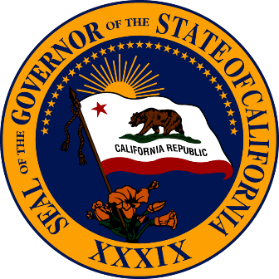

***Draft Agenda***
Governor’s Military Council
Business Meeting Agenda
February 3, 2017
Coast Guard Island, Alameda

10:00 – 10:15 am Welcome

10:15 – 11:00 pm Consideration of Action Items

11:00 – 11:45 pm Staff Update on Council’s Current Efforts

11:45 – 12:00 pm Break for Working Lunch

12:00 – 12:15 pm State Land Use Issues

12:15 – 1:00 pm Transfer proceedings to Closed Session (pursuant to Government Code
§11126(f)(4))

1:00 pm Adjourn Closed Session

1:00 – 1:45 pm Discussion with USCG D11 Leadership (TENTATIVE)

1:45 – 2:00 pm Public Comment

2:00 pm Adjourn

Public Notice
A notice to all members of the public attending. Each person wishing to speak before the Governor’s Military Council shall submit a "Speaker Slip" to Rito Guerra, Council Policy Advisor, which will be made available at the event. During the designated time please raise your hand and the Chair will recognize you. Staff will hand you a microphone to state your name and any affiliation. Each speaker will have up to three minutes to speak at the discretion of the Chair. Your information may be received and discussed or placed on a future agenda. State law generally precludes the Council from discussing or acting upon any topic presented during Public Comment that is not on the meeting’s published agenda. Note: There is a time limit of 30 minutes for public comment. Each speaker will be heard in the order of submission of a Speaker Slip. All above times are approximate and subject to change.

All times set forth herein are for convenience only. The time set forth does not necessarily reflect the actual time an item will be heard by the board.

