CURRENT VERSION: AS OF 11AUG22
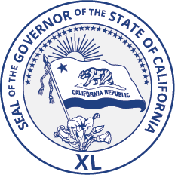

Governor’s Military Council Q3 2022 Business Meeting Agenda
August 29, 2022
Embassy Suites, 100 Capitol Mall, Tower Rm Sacramento, California 95814

1:00pm – 1:15pm Welcome

1:15pm – 1:30pm Public Comment

1:30pm – 1:40pm Consideration of Action Items
Council will consider administrative items, including: Approval of Q2 2022 Council meeting minutes

1:40pm – 3:00pm Member Agency Updates and Council Discussion Items
- Office of Planning and Research Update
- CalVet Update
- GO-Biz Update
- Mr. Khi Jackson, CA Commissioner, MIC3
- Member engagement/ small group visit updates
- 2022 Summit Discussion and new member expectations
- Upcoming engagement and event opportunities
- Q IV Meeting
3:00pm – 3:30pm Executive Director Update
- General Update
- Space Initiates

3:30pm – 4:50pm Staff Update on Council’s Current Efforts
Staff Update Brief

4:50pm – 5:00pm Final Comments
5:00pm Adjourn Public Notice
A notice to all members of the public attending. Each person wishing to speak before the Governor’s Military Council shall submit a "Speaker Slip" to Christina Justice, on-site Council Representative, which will be made available at the event. During the designated time please raise your hand and the Chair will recognize you and ask you to state your name and affiliation. Each speaker will have up to three minutes to speak at the discretion of the Chair. Your information may be received and discussed or placed on a future agenda. State law generally precludes the Council from discussing or acting upon any topic presented during Public Comment that is not on the meeting’s published agenda. Note: There is a time limit of 30 minutes for public comment.
The Council will hear Speakers in the order of submission of a Speaker Slip. All above times are approximate and subject to change.

*Updates will be provided via virtual option

